Logic Model Development©

Why develop a logic model?
Developing a logic model has two primary benefits for an organization or initiative.
Building consensus and excitement: Going through the steps of developing a logic model gives your stakeholders an opportunity to share their views and experience on what makes your initiative successful. This gives everyone a better understanding of their colleagues’ experiences and allows staff to feel valued and heard in the organization.
Supporting your initiative: A final logic model will be a concise tool that can be used for a number of purposes, including: * Describe your initiative to current and potential funders ; * Describe your initiative to other stakeholders; * Orient new staff, volunteers and partners to the initiative; * Guide evaluation and assessment efforts; and * Guide allocations of resources.
A logic model is not meant to be static. It is beneficial to review and modify logic models periodically to account for changes in resources, implementation, evaluation or assessment results, and changes to the political, economic, social and technological environment in which you work.
People involved
In developing a logic model it is very important to involve people that represent all aspects of your work, including administrative staff, those in direct service, board members or elected officials, volunteers, funders, initiative participants and community members. It is not necessary to have every stakeholder involved in every step of the process, but having each point of view represented will ensure that all perspectives, ideas and opinions are expressed.
Suggested steps
The process for developing a logic model involves meetings for brainstorming, idea refinement, revision and stakeholder endorsement. While the following steps are suggested based on our experience as resulting in a strong, supported logic model, these steps may be modified as appropriate for the unique circumstances of each initiative.
Step 1: Initial Brainstorming Meeting
At this meeting you should introduce the process and product outcomes you expect to see from the logic model and facilitate a brainstorming session to answer the following questions:
- What changes do we hope to see in our participants? What should they know, feel, or do differently after using our services?
- What do we do (what are all of our activities) to support these changes?
- Why do we think these activities are good ones? Why are those changes in participants important (our “theory of action”)?
- What information can we use to document that change?
- How does the environment in which we work support what we do? What are the external barriers to what we do? What makes our services important to our unique community?
A wide variety of perspectives should be represented during the brainstorming and the facilitator should encourage all participants to share their views and opinions.
Step 2: Drafting logic model
In this step, a small team should work together to organize the results of the brainstorming session into a logic model format and to align inputs and activities to discrete outcomes and to broad goals as applicable. The small team should be made up of individuals who have a high degree of authority for the initiative and/or direct knowledge of how the initiative is implemented and managed. The small team should note where inputs and activities, discrete outcomes and broad goals cannot be matched or aligned or seem outside of the organization’s mission and vision. The small team should also review assumptions and external factors (the Internet can be a good resource for finding substantiating or contradicting data) to change subjective terms such as “some,” “a few,” and “most” into concrete, objective numbers. This step should result in a draft logic model that can be shared back to the larger brainstorming group.
Step 3: Obtain feedback
An efficient method of obtaining feedback is through a brief survey attached to the draft logic model. This allows each stakeholder to review and reflect on the logic model draft independently, considering how the logic model fits with their own work and to make as many suggestions or notes as they like. Survey questions should be open ended and allow for the respondent to comment on each aspect of the draft logic model. The survey and logic model can be distributed to an even broader set of stakeholders than those who attended the brainstorming session to get a fuller spectrum of response. Survey questions can include but are not limited to the following:
- Are there any activities or inputs you see as missing?
- Are there any discrete outcomes or broad goals that you see in your work that are not reflected here?
- How well do the assumptions and external factors match your perspective of the environment in which we work?
- Is there any specific wording of any logic model element that you suggest modifying? How and why?
- Does the alignment of discrete outcomes to broad goals match your interpretation? Please explain.
Step 4: Final draft and presentation
The small team that packaged the draft logic model should meet to discuss the feedback received in Step 3 and revise the logic model. The final version should then be presented to staff and board members; this can occur at already scheduled staff and board meetings. Staff and board members should consider how to use the logic model going forward and make an implementation plan for its use that can be revisited periodically at future dates.
Logic model examples
Logic models can take many forms depending on what sort of guidance and information is needed. The following pages include some examples.
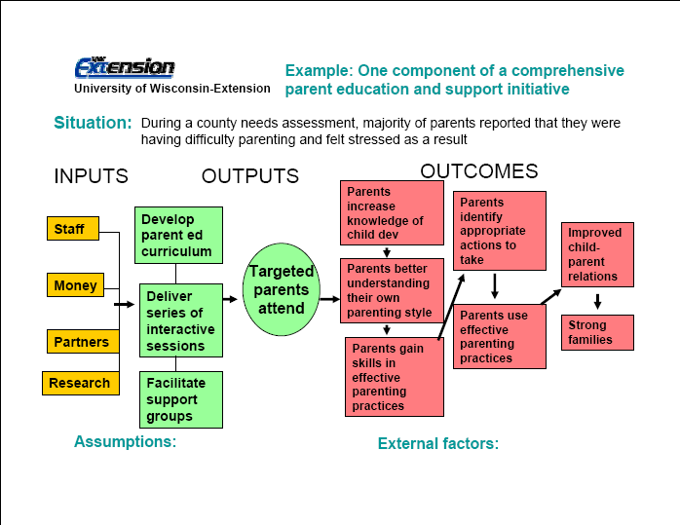
http://www.uwex.edu/ces/pdande/evaluation/pdf/Parented1002.pdf

http://www.uwex.edu/ces/pdande/evaluation/pdf/LM_CNE.pdf

http://outreach.msu.edu/CapableCommunities/examples.html#LogicModels

In the Northside Initiative, teachers, students and families are key stakeholders.

